**Decision Tree**

Decision tree algorithm falls under the category of the supervised learning. They can be used to solve both regression and classification problems.

A decision tree is a decision support tool that uses a tree-like graph or model of decisions and their possible consequences, including chance event outcomes, resource costs, and utility.

It is one way to display an algorithm. Decision trees are commonly used in operations research, specifically in decision analysis, to help identify a strategy most likely to reach a goal.

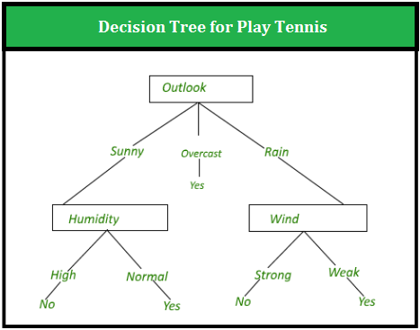

**Construction of Decision Tree:**

A tree can be “learned” by splitting the source set into subsets based on an attribute value test. This process is repeated on each derived subset in a recursive manner calledrecursive partitioning. The recursion is completed when the subset at a node all has the same value of the target variable, or when splitting no longer adds value to the predictions.

**Pseudocode:**

* 1. Find the best attribute and place it on the root node of the tree.
  2. Now, split the training set of the dataset into subsets. While making the subset make sure that each subset of training dataset should have the same value for an attribute.
  3. Find leaf nodes in all branches by repeating 1 and 2 on each subset.

The decision tree in above figure classifies a particular morning according to whether it is suitable for playing tennis and returning the classification associated with the particular leaf.(in this case Yes or No).

For example,the instance

*(Outlook = Rain, Temperature = Hot, Humidity = High, Wind = Strong)*

would be sorted down the leftmost branch of this decision tree and would therefore be classified as a negative instance.

In other words we can say that decision tree represent a disjunction of conjunctions of constraints on the attribute values of instances.

*(Outlook = Sunny ^ Humidity = Normal) v (Outllok = Overcast) v (Outlook = Rain ^ Wind = Weak)*

**Strengths and Weakness of Decision Tree approach**

The strengths of decision tree methods are:

* Decision trees are able to generate understandable rules.
* Decision trees perform classification without requiring much computation.
* Decision trees are able to handle both continuous and categorical variables.
* Decision trees provide a clear indication of which fields are most important for prediction or classification.

The weaknesses of decision tree methods:

* Decision trees are less appropriate for estimation tasks where the goal is to predict the value of a continuous attribute.
* Decision trees are prone to errors in classification problems with many class and relatively small number of training examples.
* Decision tree can be computationally expensive to train. The process of growing a decision tree is computationally expensive. At each node, each candidate splitting field must be sorted before its best split can be found. In some algorithms, combinations of fields are used and a search must be made for optimal combining weights. Pruning algorithms can also be expensive since many candidate sub-trees must be formed and compared.